# Guide to use an Automatic Teller Machine (ATM) to withdraw money

You can use this document as a guide to use an ATM to withdraw money.

## Pre-requisites

1. A **savings bank account** with any nationalized or private bank in India.
2. A valid and active **debit card**. (If you are a first-time debit card user, contact your bank’s branch to activate the card.)
3. A valid Personal Identification Number (**PIN**). (Contact your bank’s branch for first-time PIN activation.)

## Assumptions

* These instructions are specific to withdrawing money from a **Savings account**. But you may use the same instructions to withdraw money from a **Current account** with a slight alteration. Select the **Current** option instead of **Savings** option in **Step 3**.
* 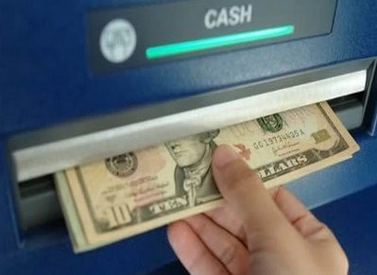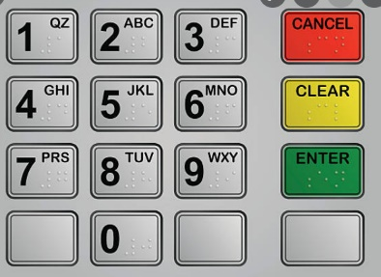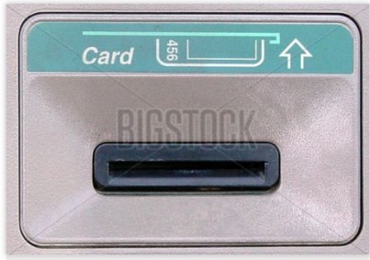ATMs may have either a **touchscreen** display or **buttons** to access the options. This document gives instructions to access a **touchscreen** display ATM. For a button-based ATM, you can use the same instructions given below, but instead of selecting an option on screen you must press the respective button near the display screen.

## Steps to withdraw money from an ATM

Use the following instructions to withdraw money from an ATM:

1. Insert your debit card in the ATM’s card slot (*Figure 1*). Ensure the magnetic strip of your card is facing down.
2. Use the keypad (*Figure 2*) on the ATM machine to enter your PIN.

**Figure 1: Card Slot**

1. Select **Savings**.
2. Select **Withdraw**.
3. Use the keypad to enter the amount you want to withdraw.

Tip: Enter the amount in multiples of 100 or 500.

1. Select **OK**.

**Figure 2: Keypad**

1. Select **OK**, if you want a withdrawal receipt, or select **Cancel**, to return to the home screen.
2. Collect the cash disbursed from the cash slot and the receipt, if you have opted for it.
3. Remove the debit card from the slot and store the debit card and cash in a safe space.

**Figure 3: Cash Slot**

Now, you have successfully withdrawn cash from an ATM.